From This To This
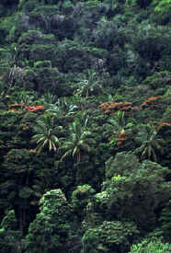 | 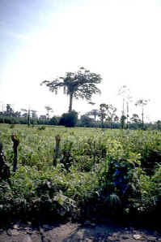
The purpose of this piece of work is to use the Internet effectively in order to find out key information about the rate of clearance, the causes, and the consequences of deforestation.
Your task is to use the answers to produce a short report about deforestation in the Amazon Rainforest. Once you have used the web links, you should delete them.
- Load up the website: http://www.enchantedlearning.com/subjects/rainforest/

  - What is a RAINFOREST?
A rainforest is…

  - Describe the STRATA of the Rainforest (STRATA means layers). There are 4 main layers:
- EMERGENTS:

- CANOPY:

- UNDERSTORY:

- FOREST FLOOR:

- What are the main reasons given for the Brazilian Rainforest being destroyed? Briefly describe each of these reasons.
http://www.mongabay.com/20brazil.htm
http://earthobservatory.nasa.gov/Library/Deforestation/
http://www.rainforestinfo.org.au/background/causes.htm

- Clearing for cattle:

- Settling by poor farmers (subsistence farming):

- Infrastructure improvements (e.g. new roads):

- Commercial farming (cash crops):

- Logging:

- What are some of the consequences of rainforests being cut down? What do we stand to lose? What problems for the earth could arise?
http://www.rain-tree.com/facts.htm
http://www.ran.org/content/fact-sheet-agribusiness-rainforest
Select the points you think are most important from the websites. Summarise them as bullet points:
- What could be done to reduce the impact (problems) of deforestation in the Amazon Rainforest? What could you personally do to try to stop deforestation?
http://www.oxfam.org.uk/coolplanet/ontheline/explore/nature/rainforest/deforest3.htm

